**COMP122 – Assignment 1 Part 2**

**Analysis and requirements:**

Write a program that displays a company’s package that provides combined broadband, TV, and mobile phone packages to a potential customer. The company has three different accounts: bronze, silver and gold. The program should display the cost per month for each account type as well as: daytime phone costs (per minute), evening/weekend phone costs (per minute), number of TV Channels, broadband (included per month), broadband cost (per GB above included amount) as well as any bonuses provided by an account. This is also demonstrated in the image below.

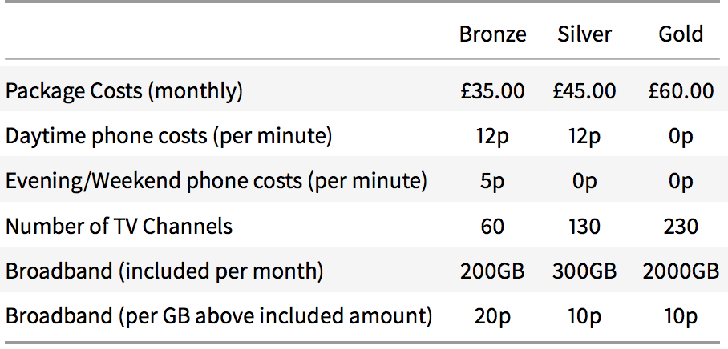

Before displaying the details of each account, the program should take as input from a potential client: the number of daytime phone minutes they use, the number of evening/weekend phone minutes they use and the amount of broadband usage, expressed in GB for a given month. The program should then display the costs and the total overall cost for each account after displaying its details. Based on the total overall cost for each account the program should then output the account that’s the cheapest.

**Design:**

Class diagram:

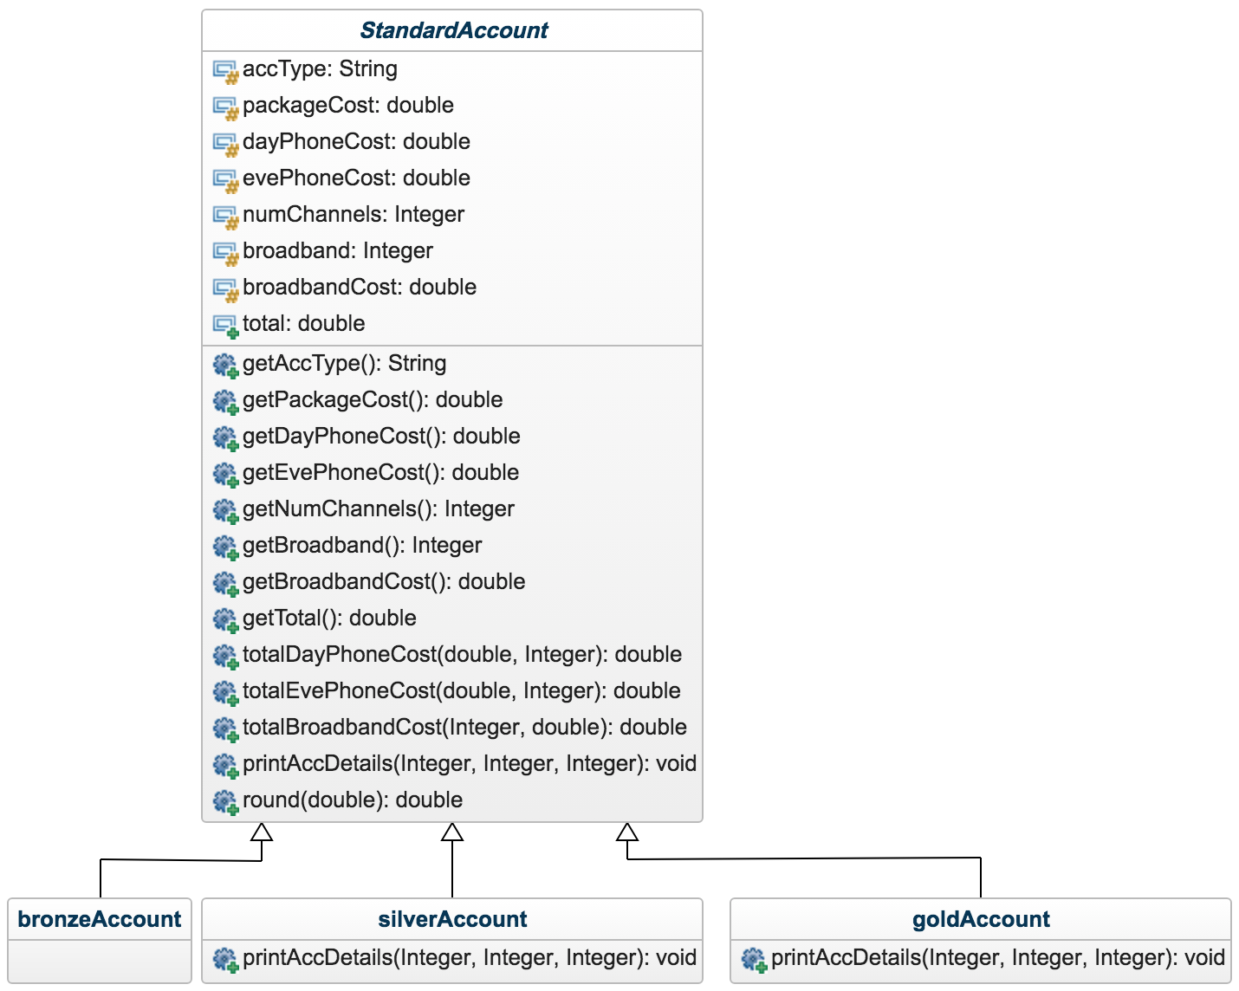

My classes are structured in this way with the account types: bronze, silver and gold as subclasses of StandardAccount - the super class. This was done as I put most of the methods for calculations in the super class and the subclasses can all access them and override any if required – printAccDetails is overridden in SilverAccount and GoldAccount as they need to print some extra information.

Pseudocode:

Function that calculates the cost of broadband:

**FUNCTION** totalBroadbandCost(broadband, broadbandCost, broadbandUsage)

**BEGIN**

**IF**(broadbandUsage - broadband > 0)

(

total += (broadbandUsage - broadband) * broadbandCost

**RETURN** (broadbandUsage - broadband) * broadbandCost

)

**ELSE**

(

**RETURN** 0

)

**END**

Getting the number of daytime minutes used by the user – allowing no negative number to be stored:

**REPEAT**

(

**PRINT** "Please enter the number of daytime minutes used per month:"

dayMins = getInput()

) **UNTIL** (dayMins < 0)

Getting the number of evening and weekend minutes used by the user – allowing no negative number to be stored:

**REPEAT**

(

**PRINT** "Please enter the number of nighttime minutes used per month:"

eveningOrWeekendMins = getInput()

) **UNTIL** (eveningOrWeekendMins < 0)

Getting the number of Gigabytes used per month:

**REPEAT**

(

**PRINT** "Please enter the number of Gigabytes used per month:"

broadbandUsage = getInput()

) **UNTIL** (broadbandUsage < 0)

Working out which account has the cheapest overall total cost:

**IF** (bronzeTotal < silverTotal AND bronzeTotal < goldTotal)

(

**PRINT** “Bronze account is cheapest cost"

)

**ELSE IF** ((silverTotal < bronzeTotal AND silverTotal < goldTotal) OR silverTotal == bronzeTotal)

(

**PRINT** “Silver account is cheapest cost"

)

**ELSE IF** ((goldTotal < bronzeTotal AND goldTotal < silverTotal) OR goldTotal == bronzeTotal OR goldTotal == silverTotal)

(

**PRINT** “Gold account is cheapest cost"

)

My approach here was to output the higher ranked account as the cheapest if 2 accounts have the same total cost and the same if 3 accounts have the same total cost.

**Testing:**

**Important note:** ‘Display details’ in the expected result column of the results table means the program should print out the details and costs (which are constant for each type of account). E.g

Bronze account:

Display details

=

Account summary for Bronze account

Package cost: 35.0

Cost of daytime calls: 0.12/min

Cost of evening and weekend calls: 0.05/min

Number of Channels: 60

Broadband Included: 200GB

Broadband Cost (above included limit): 0.2/GB

Silver account:

Display details

=

Account summary for Silver account

Package cost: 45.0

Cost of daytime calls: 0.12/min

Cost of evening and weekend calls: 0.0/min

Number of Channels: 130

Broadband Included: 300GB

Broadband Cost (above included limit): 0.1/GB

Second note: Actual result is copied and pasted output from terminal as opposed to screenshots as this fits the table cleaner.

Gold account:

Display details

=

Account summary for Gold account

Package cost: 60.0

Cost of daytime calls: 0.0/min

Cost of evening and weekend calls: 0.0/min

Number of Channels: 230

Broadband Included: 2000GB

Broadband Cost (above included limit): 0.1/GB

|  |  |  |
| --- | --- | --- |
| **Test data + Reason** | **Expected result** | **Actual result + Pass/Fail** |
| Daytime mins: 100  Evening/weekend mins: 100  GB used: 325  Use the same test data as in the assignment brief. | Bronze account:  Display details  Total daytime calls cost: 12.0  Total evening calls cost: 5.0  Total (extra) broadband cost: 25.0  Total cost: 77.0  Silver account: Display details  Total daytime calls cost: 12.0  Total evening calls cost: 0.0  Total (extra) broadband cost: 2.5  Total cost: 59.5  Spotify Account provided  Gold account:  Display details  Total daytime calls cost: 0.0  Total evening calls cost: 0.0  Total (extra) broadband cost: 0.0  Total cost: 60.0  Spotify Account provided  Music On Demand provided  Silver account is cheapest cost | Please enter the number of daytime minutes used per month: 100  Please enter the number of nighttime minutes used per month: 100  Please enter the number of Gigabytes used per month: 325  Account summary for Bronze account  Package cost: 35.0  Cost of daytime calls: 0.12/min  Cost of evening and weekend calls: 0.05/min  Number of Channels: 60  Broadband Included: 200GB  Broadband Cost (above included limit): 0.2/GB  Total daytime calls cost: 12.0  Total evening calls cost: 5.0  Total (extra) broadband cost: 25.0  Total cost: 77.0  Account summary for Silver account  Package cost: 45.0  Cost of daytime calls: 0.12/min  Cost of evening and weekend calls: 0.0/min  Number of Channels: 130  Broadband Included: 300GB  Broadband Cost (above included limit): 0.1/GB  Total daytime calls cost: 12.0  Total evening calls cost: 0.0  Total (extra) broadband cost: 2.5  Total cost: 59.5  Spotify Account provided  Account summary for Gold account  Package cost: 60.0  Cost of daytime calls: 0.0/min  Cost of evening and weekend calls: 0.0/min  Number of Channels: 230  Broadband Included: 2000GB  Broadband Cost (above included limit): 0.1/GB  Total daytime calls cost: 0.0  Total evening calls cost: 0.0  Total (extra) broadband cost: 0.0  Total cost: 60.0  Spotify Account provided  Music On Demand provided  Silver account is cheapest cost  Pass |
| Daytime mins: 0  Evening/weekend mins: 0  GB used: 0  See if program behaves correctly if 0 is inputted for each input. | Bronze account:  Display details  Total daytime calls cost: 0.0  Total evening calls cost: 0.0  Total (extra) broadband cost: 0.0  Total cost: 35.0  Silver account: Display details  Total daytime calls cost: 0.0  Total evening calls cost: 0.0  Total (extra) broadband cost: 0.0  Total cost: 45.0  Spotify Account provided  Gold account:  Display details  Total daytime calls cost: 0.0  Total evening calls cost: 0.0  Total (extra) broadband cost: 0.0  Total cost: 60.0  Spotify Account provided  Music On Demand provided  Bronze account is cheapest cost | Please enter the number of daytime minutes used per month: 0  Please enter the number of nighttime minutes used per month: 0  Please enter the number of Gigabytes used per month: 0  Account summary for Bronze account  Package cost: 35.0  Cost of daytime calls: 0.12/min  Cost of evening and weekend calls: 0.05/min  Number of Channels: 60  Broadband Included: 200GB  Broadband Cost (above included limit): 0.2/GB  Total daytime calls cost: 0.0  Total evening calls cost: 0.0  Total (extra) broadband cost: 0.0  Total cost: 35.0  Account summary for Silver account  Package cost: 45.0  Cost of daytime calls: 0.12/min  Cost of evening and weekend calls: 0.0/min  Number of Channels: 130  Broadband Included: 300GB  Broadband Cost (above included limit): 0.1/GB  Total daytime calls cost: 0.0  Total evening calls cost: 0.0  Total (extra) broadband cost: 0.0  Total cost: 45.0  Spotify Account provided  Account summary for Gold account  Package cost: 60.0  Cost of daytime calls: 0.0/min  Cost of evening and weekend calls: 0.0/min  Number of Channels: 230  Broadband Included: 2000GB  Broadband Cost (above included limit): 0.1/GB  Total daytime calls cost: 0.0  Total evening calls cost: 0.0  Total (extra) broadband cost: 0.0  Total cost: 60.0  Spotify Account provided  Music On Demand provided  Bronze account is cheapest cost  Pass |
| Daytime mins: 200  Evening/weekend mins: 150  GB used: 1900  Use ‘normal’ day and evening minutes but large broadband usage. | Bronze account:  Display details  Total daytime calls cost: 24.0  Total evening calls cost: 7.5  Total (extra) broadband cost: 340.0  Total cost: 406.5  Silver account: Display details  Total daytime calls cost: 24.0  Total evening calls cost: 0.0  Total (extra) broadband cost: 160.0  Total cost: 229.0  Spotify Account provided  Gold account:  Display details  Total daytime calls cost: 0.0  Total evening calls cost: 0.0  Total (extra) broadband cost: 0.0  Total cost: 60.0  Spotify Account provided  Music On Demand provided  Gold account is cheapest cost | Please enter the number of daytime minutes used per month: 200  Please enter the number of nighttime minutes used per month: 150  Please enter the number of Gigabytes used per month: 1900  Account summary for Bronze account  Package cost: 35.0  Cost of daytime calls: 0.12/min  Cost of evening and weekend calls: 0.05/min  Number of Channels: 60  Broadband Included: 200GB  Broadband Cost (above included limit): 0.2/GB  Total daytime calls cost: 24.0  Total evening calls cost: 7.5  Total (extra) broadband cost: 340.0  Total cost: 406.5  Account summary for Silver account  Package cost: 45.0  Cost of daytime calls: 0.12/min  Cost of evening and weekend calls: 0.0/min  Number of Channels: 130  Broadband Included: 300GB  Broadband Cost (above included limit): 0.1/GB  Total daytime calls cost: 24.0  Total evening calls cost: 0.0  Total (extra) broadband cost: 160.0  Total cost: 229.0  Spotify Account provided  Account summary for Gold account  Package cost: 60.0  Cost of daytime calls: 0.0/min  Cost of evening and weekend calls: 0.0/min  Number of Channels: 230  Broadband Included: 2000GB  Broadband Cost (above included limit): 0.1/GB  Total daytime calls cost: 0.0  Total evening calls cost: 0.0  Total (extra) broadband cost: 0.0  Total cost: 60.0  Spotify Account provided  Music On Demand provided  Gold account is cheapest cost  Pass |
| Daytime mins: 100  Evening/weekend mins: 100  GB used: 330  Use data that results in the silver and gold accounts having the same total cost. | Bronze account:  Display details  Total daytime calls cost: 12.0  Total evening calls cost: 5.0  Total (extra) broadband cost: 26.0  Total cost: 78.0  Silver account: Display details  Total daytime calls cost: 12.0  Total evening calls cost: 0.0  Total (extra) broadband cost: 3.0  Total cost: 60.0  Spotify Account provided  Gold account:  Display details  Total daytime calls cost: 0.0  Total evening calls cost: 0.0  Total (extra) broadband cost: 0.0  Total cost: 60.0  Spotify Account provided  Music On Demand provided  Gold account is cheapest cost | Please enter the number of daytime minutes used per month: 100  Please enter the number of nighttime minutes used per month: 100  Please enter the number of Gigabytes used per month: 330  Account summary for Bronze account  Package cost: 35.0  Cost of daytime calls: 0.12/min  Cost of evening and weekend calls: 0.05/min  Number of Channels: 60  Broadband Included: 200GB  Broadband Cost (above included limit): 0.2/GB  Total daytime calls cost: 12.0  Total evening calls cost: 5.0  Total (extra) broadband cost: 26.0  Total cost: 78.0  Account summary for Silver account  Package cost: 45.0  Cost of daytime calls: 0.12/min  Cost of evening and weekend calls: 0.0/min  Number of Channels: 130  Broadband Included: 300GB  Broadband Cost (above included limit): 0.1/GB  Total daytime calls cost: 12.0  Total evening calls cost: 0.0  Total (extra) broadband cost: 3.0  Total cost: 60.0  Spotify Account provided  Account summary for Gold account  Package cost: 60.0  Cost of daytime calls: 0.0/min  Cost of evening and weekend calls: 0.0/min  Number of Channels: 230  Broadband Included: 2000GB  Broadband Cost (above included limit): 0.1/GB  Total daytime calls cost: 0.0  Total evening calls cost: 0.0  Total (extra) broadband cost: 0.0  Total cost: 60.0  Spotify Account provided  Music On Demand provided  Gold account is cheapest cost  Pass |
| Daytime mins: 50  Evening/weekend mins: 80  GB used: 230  Use data that results in the bronze and silver accounts having the same total cost. | Bronze account:  Display details  Total daytime calls cost: 6.0  Total evening calls cost: 4.0  Total (extra) broadband cost: 6.0  Total cost: 51.0  Silver account: Display details  Total daytime calls cost: 6.0  Total evening calls cost: 0.0  Total (extra) broadband cost: 0.0  Total cost: 51.0  Spotify Account provided  Gold account:  Display details  Total daytime calls cost: 0.0  Total evening calls cost: 0.0  Total (extra) broadband cost: 0.0  Total cost: 60.0  Spotify Account provided  Music On Demand provided  Silver account is cheapest cost | Please enter the number of daytime minutes used per month: 50  Please enter the number of nighttime minutes used per month: 80  Please enter the number of Gigabytes used per month: 230  Account summary for Bronze account  Package cost: 35.0  Cost of daytime calls: 0.12/min  Cost of evening and weekend calls: 0.05/min  Number of Channels: 60  Broadband Included: 200GB  Broadband Cost (above included limit): 0.2/GB  Total daytime calls cost: 6.0  Total evening calls cost: 4.0  Total (extra) broadband cost: 6.0  Total cost: 51.0  Account summary for Silver account  Package cost: 45.0  Cost of daytime calls: 0.12/min  Cost of evening and weekend calls: 0.0/min  Number of Channels: 130  Broadband Included: 300GB  Broadband Cost (above included limit): 0.1/GB  Total daytime calls cost: 6.0  Total evening calls cost: 0.0  Total (extra) broadband cost: 0.0  Total cost: 51.0  Spotify Account provided  Account summary for Gold account  Package cost: 60.0  Cost of daytime calls: 0.0/min  Cost of evening and weekend calls: 0.0/min  Number of Channels: 230  Broadband Included: 2000GB  Broadband Cost (above included limit): 0.1/GB  Total daytime calls cost: 0.0  Total evening calls cost: 0.0  Total (extra) broadband cost: 0.0  Total cost: 60.0  Spotify Account provided  Music On Demand provided  Silver account is cheapest cost  Pass |
| Daytime mins: 120  Evening/weekend mins: 240  GB used: 2500.  Use a high broadband usage that’s above the gold accounts limit. | Bronze account:  Display details  Total daytime calls cost: 14.4  Total evening calls cost: 12.0  Total (extra) broadband cost: 460.0  Total cost: 521.4  Silver account: Display details  Total daytime calls cost: 14.4  Total evening calls cost: 0.0  Total (extra) broadband cost: 220.0  Total cost: 279.4  Spotify Account provided  Gold account:  Display details  Total daytime calls cost: 0.0  Total evening calls cost: 0.0  Total (extra) broadband cost: 50.0  Total cost: 110.0  Spotify Account provided  Music On Demand provided  Gold account is cheapest cost | Please enter the number of daytime minutes used per month: 120  Please enter the number of nighttime minutes used per month: 240  Please enter the number of Gigabytes used per month: 2500  Account summary for Bronze account  Package cost: 35.0  Cost of daytime calls: 0.12/min  Cost of evening and weekend calls: 0.05/min  Number of Channels: 60  Broadband Included: 200GB  Broadband Cost (above included limit): 0.2/GB  Total daytime calls cost: 14.4  Total evening calls cost: 12.0  Total (extra) broadband cost: 460.0  Total cost: 521.4  Account summary for Silver account  Package cost: 45.0  Cost of daytime calls: 0.12/min  Cost of evening and weekend calls: 0.0/min  Number of Channels: 130  Broadband Included: 300GB  Broadband Cost (above included limit): 0.1/GB  Total daytime calls cost: 14.4  Total evening calls cost: 0.0  Total (extra) broadband cost: 220.0  Total cost: 279.4  Spotify Account provided  Account summary for Gold account  Package cost: 60.0  Cost of daytime calls: 0.0/min  Cost of evening and weekend calls: 0.0/min  Number of Channels: 230  Broadband Included: 2000GB  Broadband Cost (above included limit): 0.1/GB  Total daytime calls cost: 0.0  Total evening calls cost: 0.0  Total (extra) broadband cost: 50.0  Total cost: 110.0  Spotify Account provided  Music On Demand provided  Gold account is cheapest cost  Pass |
| Daytime mins: 125  Evening/weekend mins: 120  GB used: 220  Use input data that results in all accounts having the same total cost. | Bronze account:  Display details  Total daytime calls cost: 15.0  Total evening calls cost: 6.0  Total (extra) broadband cost: 4.0  Total cost: 60.0  Silver account: Display details  Total daytime calls cost: 15.0  Total evening calls cost: 0.0  Total (extra) broadband cost: 0.0  Total cost: 60.0  Spotify Account provided  Gold account:  Display details  Total daytime calls cost: 0.0  Total evening calls cost: 0.0  Total (extra) broadband cost: 0.0  Total cost: 60.0  Spotify Account provided  Music On Demand provided  Gold account is cheapest cost | Please enter the number of daytime minutes used per month: 125  Please enter the number of nighttime minutes used per month: 120  Please enter the number of Gigabytes used per month: 220  Account summary for Bronze account  Package cost: 35.0  Cost of daytime calls: 0.12/min  Cost of evening and weekend calls: 0.05/min  Number of Channels: 60  Broadband Included: 200GB  Broadband Cost (above included limit): 0.2/GB  Total daytime calls cost: 15.0  Total evening calls cost: 6.0  Total (extra) broadband cost: 4.0  Total cost: 60.0  Account summary for Silver account  Package cost: 45.0  Cost of daytime calls: 0.12/min  Cost of evening and weekend calls: 0.0/min  Number of Channels: 130  Broadband Included: 300GB  Broadband Cost (above included limit): 0.1/GB  Total daytime calls cost: 15.0  Total evening calls cost: 0.0  Total (extra) broadband cost: 0.0  Total cost: 60.0  Spotify Account provided  Account summary for Gold account  Package cost: 60.0  Cost of daytime calls: 0.0/min  Cost of evening and weekend calls: 0.0/min  Number of Channels: 230  Broadband Included: 2000GB  Broadband Cost (above included limit): 0.1/GB  Total daytime calls cost: 0.0  Total evening calls cost: 0.0  Total (extra) broadband cost: 0.0  Total cost: 60.0  Spotify Account provided  Music On Demand provided  Gold account is cheapest cost  Pass |
| Daytime mins: -1,-7,100  Evening/weekend mins: -100,120  GB used: -56,250  Use negative inputs to see if program behaves correctly | Please enter the number of daytime minutes used per month: -1  Please enter the number of daytime minutes used per month: -7  Please enter the number of daytime minutes used per month: 100  Please enter the number of nighttime minutes used per month: -100  Please enter the number of nighttime minutes used per month: 120  Please enter the number of Gigabytes used per month: -56  Please enter the number of Gigabytes used per month: 250  Bronze account:  Display details  Display totals  Silver account:  Display details  Display totals  Gold account:  Display details  Display totals  Output cheapest account | Please enter the number of daytime minutes used per month: -1  Please enter the number of daytime minutes used per month: -7  Please enter the number of daytime minutes used per month: 100  Please enter the number of nighttime minutes used per month: -100  Please enter the number of nighttime minutes used per month: 120  Please enter the number of Gigabytes used per month: -56  Please enter the number of Gigabytes used per month: 250  Account summary for Bronze account  Package cost: 35.0  Cost of daytime calls: 0.12/min  Cost of evening and weekend calls: 0.05/min  Number of Channels: 60  Broadband Included: 200GB  Broadband Cost (above included limit): 0.2/GB  Total daytime calls cost: 12.0  Total evening calls cost: 6.0  Total (extra) broadband cost: 10.0  Total cost: 63.0  Account summary for Silver account  Package cost: 45.0  Cost of daytime calls: 0.12/min  Cost of evening and weekend calls: 0.0/min  Number of Channels: 130  Broadband Included: 300GB  Broadband Cost (above included limit): 0.1/GB  Total daytime calls cost: 12.0  Total evening calls cost: 0.0  Total (extra) broadband cost: 0.0  Total cost: 57.0  Spotify Account provided  Account summary for Gold account  Package cost: 60.0  Cost of daytime calls: 0.0/min  Cost of evening and weekend calls: 0.0/min  Number of Channels: 230  Broadband Included: 2000GB  Broadband Cost (above included limit): 0.1/GB  Total daytime calls cost: 0.0  Total evening calls cost: 0.0  Total (extra) broadband cost: 0.0  Total cost: 60.0  Spotify Account provided  Music On Demand provided  Silver account is cheapest cost  Pass |

Part d)

Create a class called ‘Platinum Account’ and make it extend the GoldAccount class. Create a method getBroadband which will override the method in the StandardAccount and this method should now return a string. Create another method getTotalBroadband which will also override the method with the same name In the StandardAccount class and make it return 0 as the Platinum Account has no cost for broadband usage. Finally instantiate a new object, which will be of type Platinum Account, in the AccountUser class, where the main method resides, with the parameters that define a Platinum Account and for the broadband parameter just input 0.